**Assignment-3 (Central Tendency & Dispersion)**

**EXERCISE 1.**

| **16** | **15** | **12** | **15** | **10** | **16** | **16** | **15** | **15** | **15** | **12** | **18** | **12** | **14** | **10** | **18** | **15** | **14** | **15** | **15** |
| --- | --- | --- | --- | --- | --- | --- | --- | --- | --- | --- | --- | --- | --- | --- | --- | --- | --- | --- | --- |

Sum of the data is 288.So,

***Mean*** = 288/20 = ***14.4***

In order to find the median, we need to sort the set. Median will be the number in the middle.

***Median = 15***

Mode is the most frequent score in a data set.

***Mode = 15***

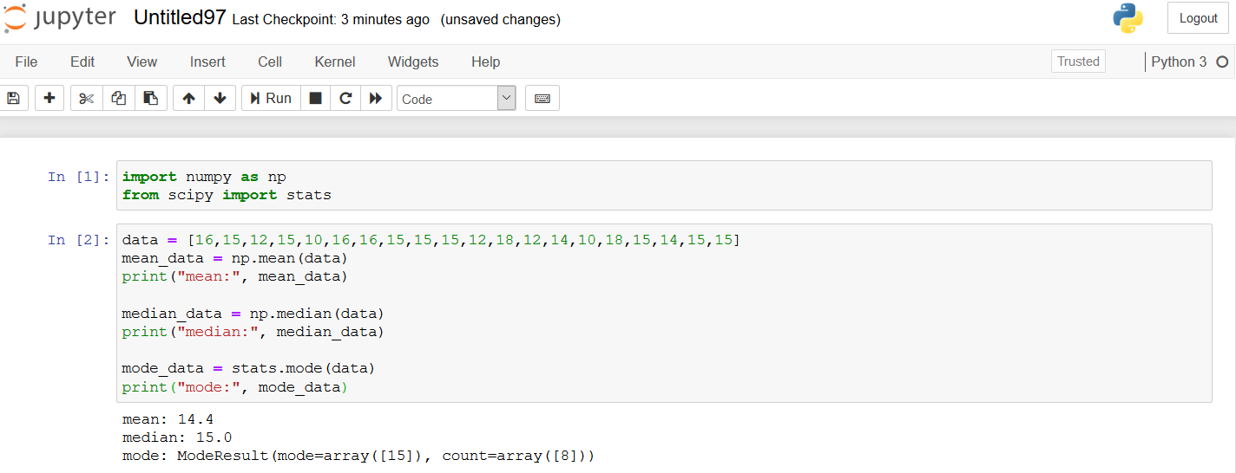

**EXERCISE 2.**

10 9 7 9 8 9 5 4

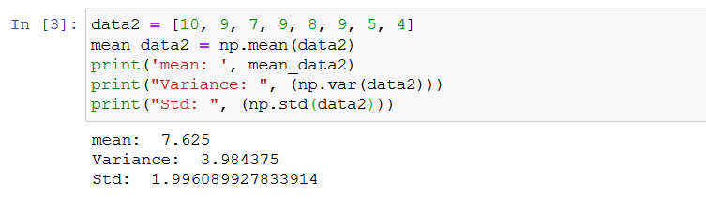

**EXERCISE 3.**

*salary = [120, 80, 85, 85, 80, 83, 100, 105, 105, 85, 75, 125, 120, 105, 85, 80, 95, 90, 95, 85, 80, 85, 120, 100, 105, 90]*

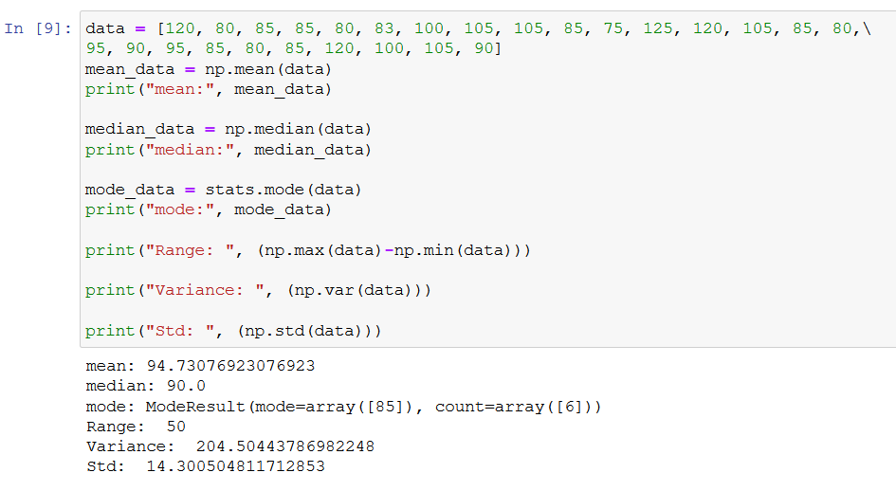

Sorted list is: [75, 80, 80, 80, 80, 83, 85, 85, 85, 85, 85, 85, 90, 90, 95, 95, 100, 100, 105, 105, 105, 105, 120, 120, 120, 125]

Median = 90

Q1 = 85

Q3 = 105

***IQR*** = Q3 – Q1 = 105 – 85 = ***20***

Outliers: (Q1 - 1.5 * IQR) or (Q3 + 1.5 * IQR)

Lower Outlier: (85-30) = 55

Upper Outlier: (105+30) = 135

**Conclusions**:

* There are no outliers.
* Mean, median and range are different values, but they are close to each other.
* STD value (14.3) will cause a wider spread.